NORWALK EAGLES #711
NOVEMBER 2022 NEWSLETTER
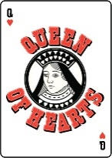  Queen of Hearts  The Queen drawing is on Mondays at 7:00 pm. Tickets are on sale at the bar daily or can be purchased at Queen  table on Monday from 5:30 – 6:30 pm.  Kitchen open from 4:30 – 7:00 pm. | VETERANS’ DAY  RECOGNITION DINNER  To honor our veterans, any veteran who is a Norwalk Eagles member, will receive a free Tuesday special dinner at the  Eagles Club on Tuesday, November 8th.  Thank you for your service!
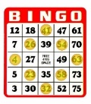  Norwalk Humane Society Bingo  at the Norwalk Eagles Club  Wednesday, November 2nd & December 7th  Doors Open: 4:30 pm  Early Bird: 5:30 pm Regular Bingo: 6:00 pm  *Open to the Public*  Must be 18 years or older | 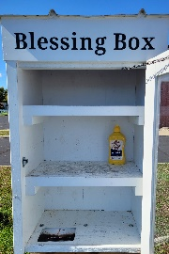  Blessing Box  Our Blessing Box needs your help especially during the holiday season. Canned or packaged goods can be placed in the Blessing Box or money can be donated at the kitchen to purchase items. Thank you for your support!
American Red Cross  Norwalk Community Blood Drive  at the Norwalk Eagles Club  Wednesday, November 8th  11:30 am to 5:30 pm  To schedule an appointment visit  RedCrossBlood.org and enter sponsor code: Eagle  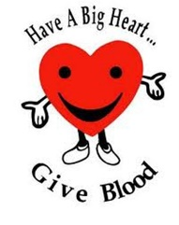  or call 1-800-RED-CROSS.  FYI: One pint of blood can save three lives! | This Photo by Unknown Author is licensed under CC BY  Karaoke with Wess  Friday, November 4th & 18th  7:30 – 10:00 pm  “Music is the soundtrack of your life.”  $\sim$Dick Clark$\sim$
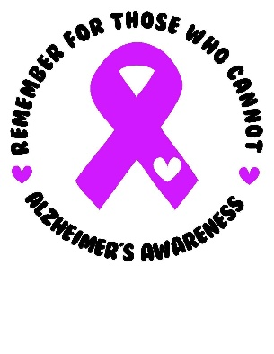  Spaghetti Dinner to Support  Alzheimer’s Awareness  Sunday, November 6th  1:00 – 4:00 pm  Sponsored by the Norwalk Eagles  Ladies Auxiliary.  “There is one thing Alzheimer’s cannot take away, and that is love. Love is not a memory – it’s a feeling that resides in your heart and soul.”  -www.fadetoblank.org- | Saturday, November 19th  The Norwalk Eagles Club  proudly presents comedians  Nick Dlouhy and Kirk Bogos!  Tickets: $20 per person  (May be purchased at the bar or at the door.)  Includes an array of heavy hors d’oeuvres!  Cocktails and Hors d’oeuvres at 7:00 pm.  Show starts at 8:00 pm.  This event is open to the public.  Must be 21 or older!
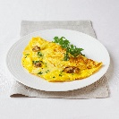  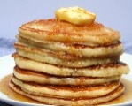  Norwalk Eagle Riders  Pancake & Omelet Breakfast  Sunday, November 27th  8:00 am – 12:00 pm  Open to the Public  Menu Includes: Pancakes, Made to Order Omelets, Sausage, Potatoes, Biscuites & Gravy, Fruit,  Coffee, Milk & Juice  Price: Donations Only  Club Meetings  Aerie: Nov 1st & 15th @ 7:00 pm  Auxiliary: Nov 8th @ 7:30 pm  Nov 22 @ 6:30 pm (New Time)  Eagle Riders: Nov 27th @ 1:00 pm  District Meeting: Nov 13th @ 2:00 pm in Norwalk  ******************************************************************  Club Phone Numbers  Trustees’ Office: 419-668-5602  Aerie Secretary: 419-663-7327  Kitchen: 419-663-5482  Bar: 419-668-9002  Auxiliary President (Cheryl Leon): 419-677-9083  Auxiliary Secretary (Karen Ritter): 419-577-4425 | “ “Drinksgiving” Gathering  Thanksgiving Eve  Wednesday, November 23rd  Drink Specials All Day  Ham Dinner $8.00  Regular Wednesday Menu Too!  Open Jukebox from 7:00 - 11:00 pm!  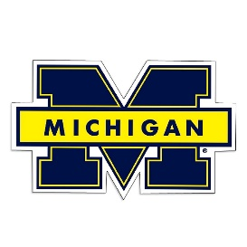  This Photo by Unknown Author is licensed under CC BY-SA  vs  Saturday, November 26th  Game Starts at Noon  Trivia Game  50/50  Best Dressed OSU & U of M Fan Contest  Join us and cheer for your favorite team!
Save the Date!  December 11th  Kids’ Christmas Breakfast  9:00 am – 12:00 pm  Santa will arrive at 10:30.  Children 12 and under will  receive a gift bag from Santa!  Breakfast Menu: French Toast, Omelets & More  Adults: $10.00  Childrent 12 and under: Free | Thanksgiving Is  Thanksgiving is  a time of gratitude to God, our Creator and Provider,  whose guidance and care go before us...  and whose love is with us forever.  Thanksgiving is  a time to reflect on the changes  to remember that we, too grow and change  from one season of life to another.  Thanksgiving is  a time of changing seasons, when leaves turn golden  in Autumn’s wake and apples are crisp  in the first chill breezes of fall.  Let us remember the true meaning of Thanksgiving.  As we see the beauty of Autumn,  let us aknowledge the many blessings which are ours...  let us think of our families and friends...  and let us give thanks in our hearts.  ~Author Unkown~
Thanksgiving Humor

Thanksgiving dinner takes
18 hours to prepare.
They are consumed in 12 minutes.
Half-time takes 12 minutes.
This is not a coincidence!
~Erma Bombeck~

BIG HALL RENTAL, CARD ROOM RENTAL, &
CATERING INFORMATION
For hall or card room rentals, contact the Trustees’ Office at: 419-668-5602
Weddings – Big Hall Hourly Rental of Big Hall Card Room Rental
Members: $400 Members: $50 per hour Members: $25 per hour
Non-Members: $500 Non-Members: $75 per hour Non-Members: $40 per hour
$150 Refundable Deposit $150 Refundable Deposit $25 Refundable Deposit

Catering Available: Contact Karen in the Kitchen at: 419-663-5482

