2022 NOVEMBER MENU
Sunday | Monday | Tuesday | Wednesday | Thursday | Friday | Saturday
Kitchen Hours:  Tuesday-Saturday  11:00 am - 7:30 pm  Kitchen Phone:  419-663-5482 |  | 1  Grilled Pork Chop  Baked Potato  & Applesauce | 2  $1.00 Drink Day  Mushroom Swiss  Burger w/Fries | 3  Tacos  Taco Salad  10 oz Steak  w/One Side | 4  Perch Dinner  w/Two Sides | 5  1# T-Bone Steak  w/Two Sides
6  Browns Game  Wings & Things  12:30 – 3:00 pm | 7  Queen of Hearts  Kitchen Open  4:30-7:00 pm | 8  Grilled Chicken  Parmesan  w/Spaghetti, Salad  & Bread  Veterans who are  members eat free! | 9  $1.00 Drink Day  Cheddar Bacon  Burger w/Fries | 10  Tacos  Taco Salad  10 oz Steak  w/One Side | 11  Walleye Dinner  w/Two Sides | 12  Prime Rib Dinner  w/Two Sides
13  Browns Game  Wings & Things  12:30 – 3:00 pm | 14  Queen of Hearts  Kitchen Open  4:30-7:00 pm | 15  Ham Steak  w/Sweet Potatoes  & Vegetable | 16  $1.00 Drink Day  Rueben Sandwich  w/Chips | 17  Tacos  Taco Salad  10 oz Steak  w/One Side | 18  Grilled Salmon  w/Two Sides | 19  Lasagna  w/ Salad & Bread
20  Browns Game  Wings & Things  12:30 – 3:00 pm | 21  Queen of Hearts  Kitchen Open  4:30-7:00 pm | 22  City Chicken  w/Potatoes &  Vegetable | 23  $1.00 Drink Day  “Drinksgiving”  Ham, Mashed  Potatoes & Gravy,  Cookie | 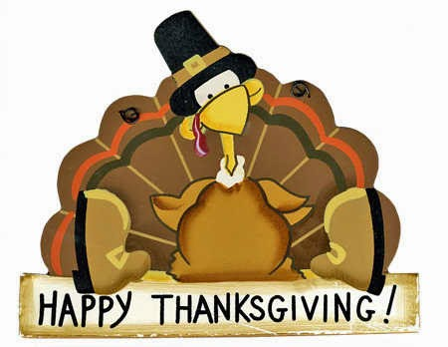  24  This Photo by Unknown Author is licensed under CC BY-NC  Kitchen Closed | 25  Fisherman’s  Platter  w/Two Sides | 26  Combo Basket
27  Browns Game  Wings & Things  12:30 – 3:00 pm | 28  Queen of Hearts  Kitchen Open  4:30-7:00 pm | 29  Country Fried  Steak  w/Potatoes &  Vegetable | 30  $1.00 Drink Day  Tuna Melt  w/Chips

