April 2022—Norwalk Eagles Activities
Sunday | Monday | Tuesday | Wednesday | Thursday | Friday | Saturday
 |  |  |  |  | 1  Karaoke  w/Wess  7:30-10:30 pm | 2  Game Night  8:00 pm  UNO  All are  welcome!
3 | 4  Queen of  Hearts  Tickets on sale at the bar.  Drawing  7:00 pm | 5  Aerie  Meeting &  Initiations  7:30 pm  Card Room | 6  $1.00  Drink Day  Humane  Society  Bingo | 7  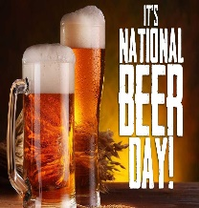 | 8  Zone Conference  Bryan, OH | 9  Zone Conference  Bryan, OH
10  Zone Conference  Bryan, OH | 11  Queen of  Hearts  Tickets on sale at the bar.  Drawing  7:00 pm | 12  Auxiliary  Meeting  7:30 pm  Card Room  Guest Speaker  Carol Wheeler  from  United Fund | 13  $1.00  Drink Day  Red Cross  Blood Drive | 14 | 15  Karaoke  w/Wess  7:30-10:30 pm | 16  Game Night  8:00 pm  LRC  Come join  in the fun!
17 | 18  Queen of  Hearts  Tickets on sale at the bar.  Drawing  7:00 pm | 19  Aerie  Meeting  7:30 pm  Card Room  Nominations  for Officers | 20  $1.00  Drink Day | 21 | 22 | 23
24  Pottery Class  2:00 – 5:00 pm  Open to the Public  Fundraiser for  Abigail Pregnancy  Services | 25  Queen of  Hearts  Tickets on sale at the bar.  Drawing  7:00 pm | 26  Auxiliary  Meeting  7:30 pm  Card Room  Nominations  for Officers | 27  $1.00  Drink Day | 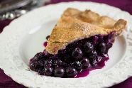  28  National  Blueberry  Pie Day | 29 | 30  Game Night  8:00 pm  Giant Jenga  &  Connect 4  Early Bird  Dues Due

